MONGODB ASSIGNMENT (QUERIES EXECUTED) :
1)test> db
test
test> use mydb
switched to db mydb
mydb> db.people.insertMany([
... { user_id: "abc1", status: "A", age: 25 },
... { user_id: "bcd2", status: "B", age: 30 },
... { user_id: "bcx3", status: "A", age: 50 },
... { user_id: "xyz4", status: "C", age: 20 },
... { user_id: "bca5", status: "A", age: 40 }
... ])
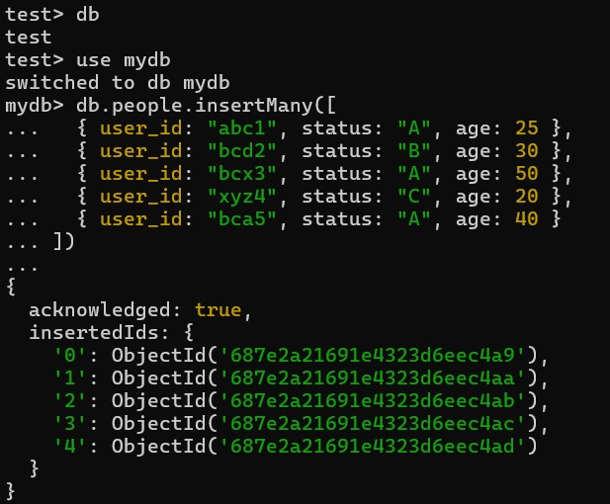

2)mydb> db.people.find()
... db.people.find({}, { user_id: 1, status: 1 })
... db.people.find({}, { user_id: 1, status: 1, _id: 0 })

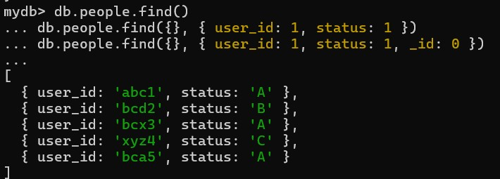

3) mydb> db.people.find({ status: "A" })
... db.people.find({ status: "A" }, { user_id: 1, statustatus: 1, _id: 0 })
... db.people.find({ status: { $ne: "A" } })
... db.people.find({ status: "A", age: 50 })
... db.people.find({ $or: [ { status: "A" }, { age: 50 } ] })
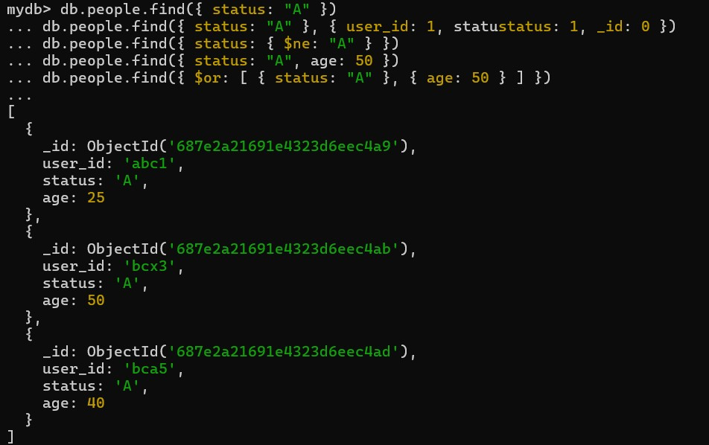

4) mydb> db.people.find({ age: { $gt: 25 } })
... db.people.find({ age: { $lt: 25 } })
... db.people.find({ age: { $gt: 25, $lte: 50 } })
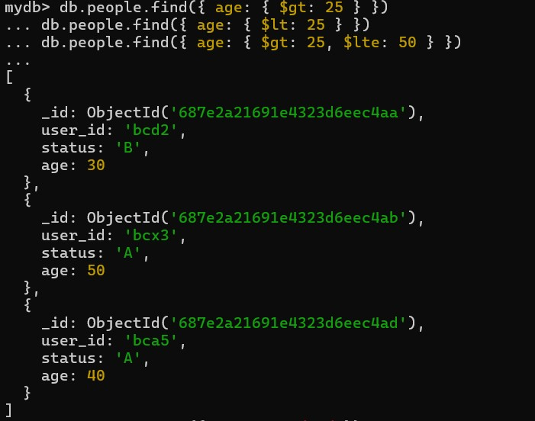

5) mydb> db.people.find({ user_id: /bc/ })
... db.people.find({ user_id: { $regex: /bc/ } })
... db.people.find({ user_id: /^bc/ })
... db.people.find({ user_id: { $regex: /^bc/ } })
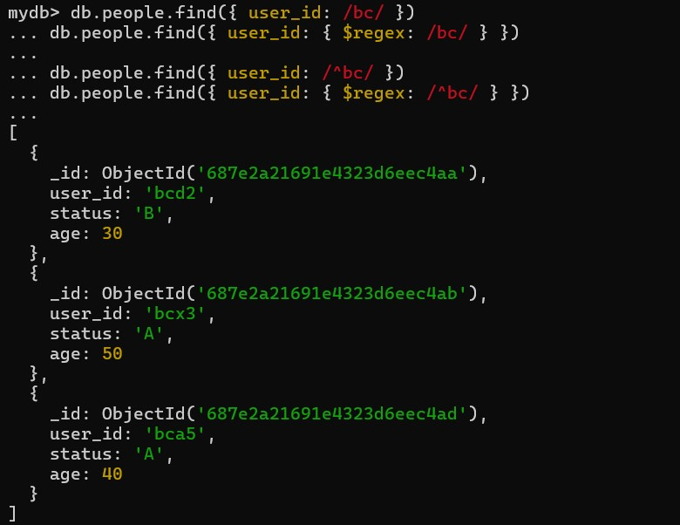
6) mydb> db.people.find({ status: "A" }).sort({ user_id: 1 }) // Ascending
... db.people.find({ status: "A" }).sort({ user_id: -1 }) // Descending
...
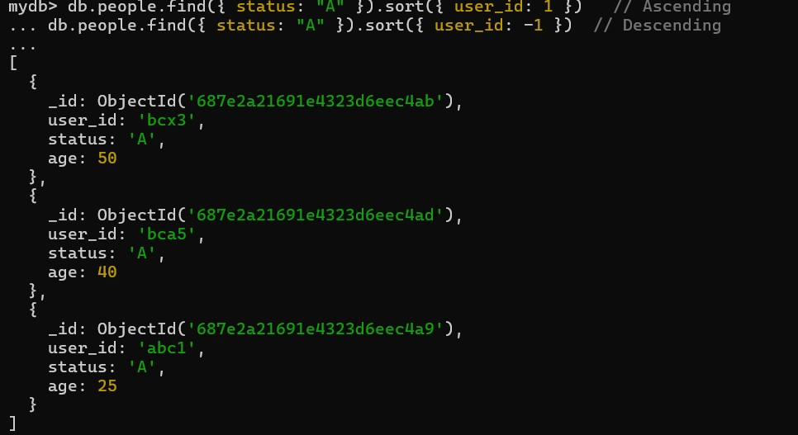

7) db.people.distinct("status")
db.people.findOne()
... db.people.find().limit(1)
... db.people.find().limit(5).skip(2) // Skip first 2, then get next 5
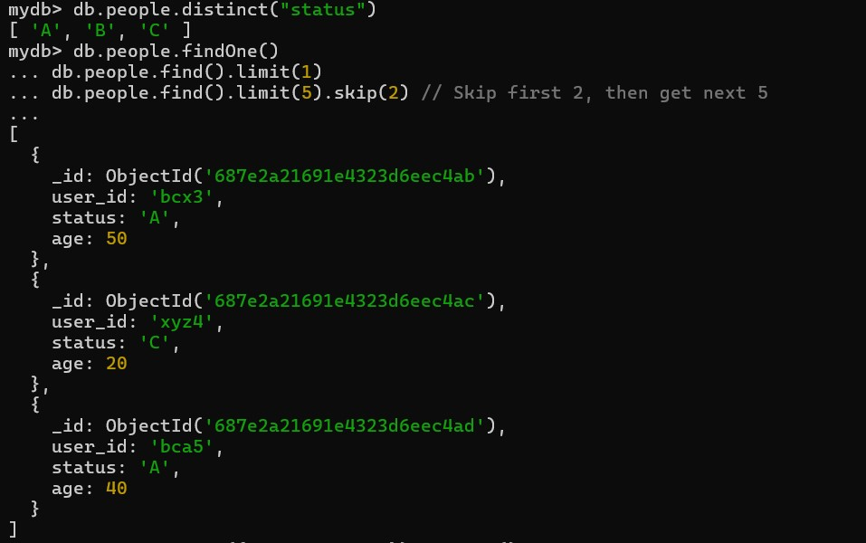
8) db.people.find({ status: "A" }).explain()
